Date: Monday, Nov 19, 2018 G.C.

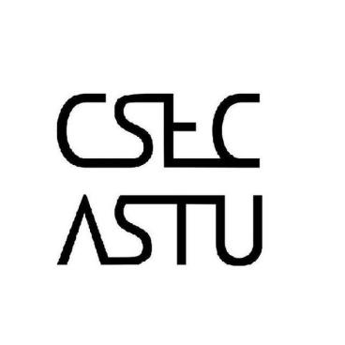 

CALL FOR ALL FRESHMAN STUDENTS WHO REGISTERED FOR THE CSEC-ICPC ENTRANCE EXAM

Your exam will be conducted on Monday ,Nov 19 ,2018. As such, all registered students are required to come by the lab and check in for the entrance exam. We will not accept students who arrive at a later time than the specified one.

Venue – B-508, R-9   
Orientation Time – Monday, Nov 19, 2018 ___

11:15 Local Time

Follow US on social Media for more updates at

**CSEC ASTU** on Telegram or on our Facebook page…